Report from Group 9 on Task 2

Report Summary

David
We initially noticed that some simple metrics significantly distinguished between singlets and doublets. The number of detected genes illustrates this:
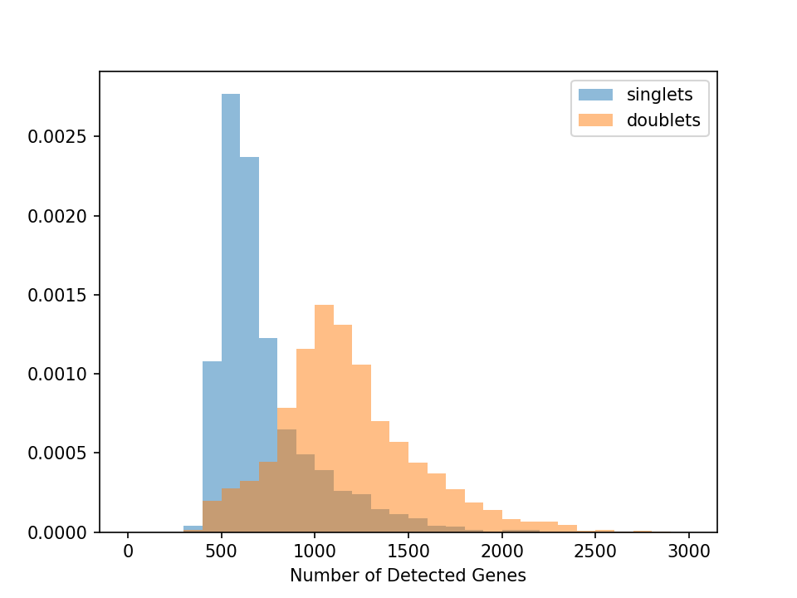
To evaluate a baseline for performance upon which to improve, we implemented a simple threshold-based classifier on this single parameter. ROC and PR curves for this are shown below:
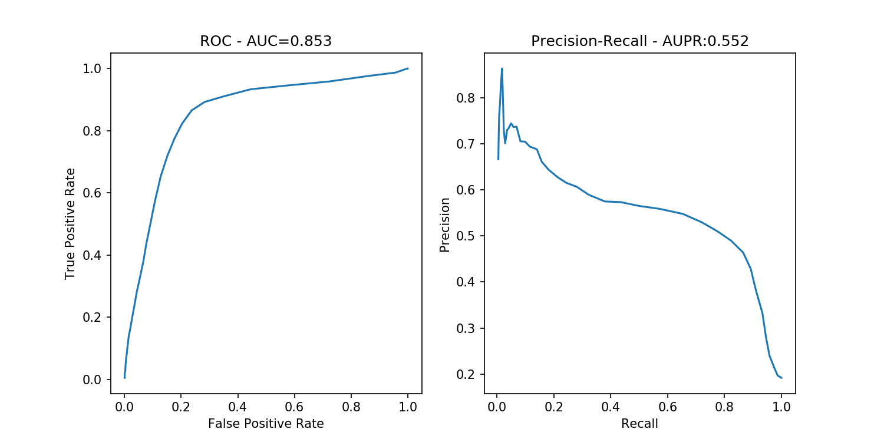

Karthik
I normalized the raw counts so that every cell sums to the median counts in the data. The normalized counts were then log-transformed after the addition of one. Using a Negative-Binomial model for the null variability in the data, I identified a set of 415 highly variable genes in the training data. The log-transformed normalized values of these genes alone were used as features for a random forest model (see below). Additionally for each cell, I included the total number of genes detected, the total number of transcripts detected and the Shannon entropy of expression (computed as -\sum{p(x)*log(p(x))}, where p(x) is the normalized expression of gene x) as 3 additional features. Next I trained a RF classifier on 70% of the training data, and tested it on the remaining 30% held out data. The classification accuracy was 10% and the AUC was 0.91. The samples were ranked based on the # of trees (probability) that voted as "singlet" or "doublet" in order to compute the AUC.
The same normalization procedure was followed for the test data, which was then supplied to the RF classifier to predict class labels and class probabilities. These were compiled for the final submission.

Nuno

Features used:
- Metrics per cell based on BAMs (PCT_CODING_BASES,PCT_UTR_BASES,PCT_INTRONIC_BASES,PCT_INTERGENIC_BASES,PCT_MRNA_BASES,PCT_USABLE_BASES,PCT_CORRECT_STRAND_READS)
- normalized expression (zscore) for a subset of genes found to have stable expression in GTex
- normalized total expression per cell (zcore)

Weka was used to explore the data and generate classifiers using different methods (SVM, decision tress, random forest, ...). Using random forest we got a classifier with 12% error, 0.88 ROC area (on 10-fold cross validation).

Nikolas
Tried different ways for simulating doublets from single single cells using dataset 1.
Initially attempted a model that mixes together different proportions of reads two randomly selected cells (make.doublets.two.groups.subsample). Two cells, one from each group (potentially overlapping) are selected such that they are not the same cell and merged by subsampling the reads in cell1 by a mix.ratio and cell2 by 1-mix.ratio.
The per-cell read distributions produced by this did not closely reflect the distributions by the known doublets. The distributions were however much more closely recapitulated when known singlets were merely added together, this is presented in the second function below.

Appendix A: Code Used

Kartik
File: Task2_code_group9_KarthikShekhar.R
# Libraries and Code
library(ggvis)
source("VarGenes.R")
library(Rtsne)
library(viridis)
library(Matrix)

# Load training Labels
trainLabels = read.table("../../../../../jovyan/jamboree/doublet-datasets/dataset1/Ye2_L001_001_train_labels.txt", row.names = 1)
colnames(trainLabels) = c("class")
cellnames = rownames(trainLabels)
trainLabels = trainLabels$class
names(trainLabels) = cellnames

# Load Training data
trainData = read.table("../../../../../jovyan/shared_scratch/group9/task2/doublets-dataset/dataset1/Ye2_L001_001_train.dge.txt.gz", header=TRUE, row.names = 1)

# Check if trainLabels cells are in the matrix and subset for cells with moderate to high complexity
cells.use = intersect(colnames(trainData), rownames(trainLabels))
cells.use = cells.use[colSums(trainData[,cells.use] > 0) > 300] # Use cells with > 300 genes

trainLabels = trainLabels[cells.use]
trainData = trainData[,cells.use]

# Metrics
numGenes = colSums(trainData > 0)
numTranscripts = colSums(trainData)
normData = scale(trainData, center=FALSE, scale=numTranscripts)
entropyData = apply(normData,2,function(x) sum(-x[x>0]*log(x[x>0]) ))

# Combine everything
df = data.frame(numGenes=numGenes, numTranscripts=numTranscripts, entropy=entropyData, cell=fullLabels)

#Some plots
df %>% ggvis(~log(numGenes), ~log(numTranscripts), fill = ~factor(cell)) %>% layer_points()
df %>% group_by(cell) %>% ggvis(~entropy, fill = ~cell) %>% layer_densities()
df %>% group_by(cell) %>% ggvis(~numGenes, fill = ~cell) %>% layer_densities()
df %>% group_by(cell) %>% ggvis(~numTranscripts, fill = ~cell) %>% layer_densities()
df %>% ggvis(~numGenes) %>% layer_densities()

# Compute variable genes variable genes using NB fit
pdf("VarGenes.pdf",w=15,h=7)
var_genes = new.meanCVfit(trainData, mean.min = 0.005, diffCV.cutoff = 0.2)
dev.off()
write(var_genes,"VariableGenes_dataset1.txt")

# PCA with log(NormCounts+1)
med_trans = median(colSums(trainData))
logNormCounts = log(med_trans*normData + 1)
pca.logNormcounts.out = princomp(t(logNormCounts[var_genes,]))
# Pick top 20 PCs
logNormCounts.scores = as.data.frame(pca.logNormcounts.out$scores[,c(1:20)])
logNormCounts.loadings = as.data.frame(pca.logNormcounts.out$loadings[,c(1:20)])

logNormCounts.scores$cell = df[rownames(logNormCounts.scores),"cell"]
logNormCounts.scores$numGenes = df[rownames(logNormCounts.scores),"numGenes"]
logNormCounts.scores$numTranscripts = df[rownames(logNormCounts.scores),"numTranscripts"]
logNormCounts.scores$entropy = df[rownames(logNormCounts.scores),"entropy"]

# PCA Plot
logNormCounts.scores %>% group_by(cell) %>% ggvis(~Comp.1, ~Comp.2, shape =~cell, stroke =~cell, size:=3) %>% layer_points()

#TSNE based on first 10 PCs
Noise = matrix(1e-5*rnorm(10*nrow(logNormCounts.scores)), nrow = nrow(logNormCounts.scores))
tsne.logNorm.out = Rtsne(X=as.matrix(logNormCounts.scores[,c(1:10)]) + Noise , theta = 0.3, pca = FALSE, verbose = TRUE)

# random Forest classification (based on variable gene normalized counts, entropy, numTranscripts and numGenes)
library(randomForest)
predictor_Data = as.matrix(logNormCounts[var_genes,])
predictor_Data = rbind(predictor_Data, dfNorm[colnames(predictor_Data), "entropy"])
predictor_Data = rbind(predictor_Data, dfNorm[colnames(predictor_Data), "numTranscripts"])
predictor_Data = rbind(predictor_Data, dfNorm[colnames(predictor_Data), "numGenes"])
rownames(predictor_Data)[c(416:418)] = c("entropy","numTranscripts","numGenes")
training.set = c(); test.set=c()
training.label = c(); test.label=c();
for (i in levels(dfNorm$cell)){
cells.in.clust = rownames(subset(dfNorm, cell == i));
n = round(length(cells.in.clust)*0.7);
train.temp = cells.in.clust[sample(length(cells.in.clust))][1:n]
test.temp = setdiff(cells.in.clust, train.temp)
training.set = c(training.set,train.temp); test.set=c(test.set,test.temp)
training.label = c(training.label, rep(i,length(train.temp))); test.label = c(test.label, rep(i, length(test.temp)));
}

# Train data
rf=randomForest(x=t(predictor_Data[,training.set]), y=factor(training.label), importance = TRUE, ntree = 301, keep.inbag=TRUE, replace=FALSE)
Conf_OOB0 = rf$confusion
test.predict = predict(rf,t(predictor_Data[,test.set]))
Conf_test = table(test.label,test.predict) # This gives an estimate of the validation accuracy on held out data
test.predict.prob = predict(rf,t(predictor_Data[,test.set]), type="prob")
#auc(test.label, test.predict.prob[,"singlet"])

# Testing

# Read data
trainData = read.table("../../../../../jovyan/shared_scratch/group9/task2/doublets-dataset/dataset1/", header=TRUE, row.names = 1)
testData_ids= read.table("../../../../../jovyan/jamboree/doublet-datasets/dataset1/Ye2_L001_001_test_labels_predict_me.txt")
testData = readMM("../../../../../jovyan/jamboree/doublet-datasets/dataset1/Ye2_sparse_molecule_counts.mtx")
cellids = read.csv("../../../../../jovyan/jamboree/doublet-datasets/dataset1/Ye2_barcode_id.csv", header = FALSE)$V2
rownames(testData) = cellids
geneids = as.character(read.csv("../../../../../jovyan/jamboree/doublet-datasets/dataset1/Ye2_gene_id.csv", header = FALSE)$V2)
colnames(testData) = geneids
testData = t(testData)
genes = intersect(rownames(testData), rownames(trainData))
testData = testData[genes,testData_ids$V1]

# Metrics
numGenesTest = colSums(testData > 0)
numTranscriptsTest = colSums(testData)
normDataTest = scale(testData, center=FALSE, scale=numTranscriptsTest)
entropyDataTest = apply(normDataTest,2,function(x) sum(-x[x>0]*log(x[x>0]) ))

med_trans1 = median(colSums(testData))
logNormCountsTest = log(med_trans1*normDataTest + 1)
logNormCountsTest = rbind(logNormCountsTest, matrix(0, nrow=4, ncol = ncol(logNormCountsTest)))
rownames(logNormCountsTest)[25645:25648] = setdiff(var_genes, rownames(testData))

# Combine everything
dfTest = data.frame(numGenes=numGenesTest, numTranscripts=numTranscriptsTest, entropy=entropyDataTest)

predictor_DataTest = as.matrix(logNormCountsTest[var_genes,])
predictor_DataTest = rbind(predictor_DataTest, dfTest[colnames(predictor_DataTest), "entropy"])
predictor_DataTest = rbind(predictor_DataTest, dfTest[colnames(predictor_DataTest), "numTranscripts"])
predictor_DataTest = rbind(predictor_DataTest, dfTest[colnames(predictor_DataTest), "numGenes"])
rownames(predictor_DataTest)[c(416:418)] = c("entropy","numTranscripts","numGenes")

# Predict using the earlier RF
final.test.predict.prob = predict(rf,t(predictor_DataTest), type="prob") # Class probabilities
final.test.predict = predict(rf,t(predictor_DataTest))

FinalOutput = data.frame(prediction = final.test.predict, doublet_prob = final.test.predict.prob[,"doublet"],
singlet_prob = final.test.predict.prob[,"singlet"])

rownames(FinalOutput) = names(final.test.predict)
write.table(FinalOutput, file = "Final_predictions_Group9_Karthik.txt", sep="\t")

File: VarGenes.R
# NEW CODE FOR ESTIMATING VARIABLE GENES
# ======================================
# Parameters:
# count.data (data.frame): [rows=genes, columns=cells] of # UMIs/cell
# diffCV.cutoff (numeric): parameter for difference in Coefficient of Variation between null dist & selected variable genes
# (Difference is in log space, so this amounts to a fold-change)
# mean.min/mean.max (numeric): crop selectable genes according to their mean
# (Use to eliminate super low noisy genes and high end if the null fits really poorly at high end.)
# main.use (character): title to display for the overall three-panel plot
# ======================================
# Returns:
# (character vector)
# List of variable genes
# ======================================

require(MASS)

new.meanCVfit <- function(count.data, diffCV.cutoff=3, mean.min=.005, mean.max=1000, main.use="", do.plot=T) {

# Format for the plot
if (do.plot) par(mfrow=c(1,3), oma=c(0,0,2,0))

# Calculate empirical mean, var and CV
mean_emp <- apply(count.data, 1, mean)
var_emp <- apply(count.data, 1, var)
cv_emp <- sqrt(var_emp) / mean_emp

# Fit gamma distribution to 'size factors' to build negative binomial
a <- colSums(count.data)
size_factor <- a/mean(a)
fit <- fitdistr(size_factor, "Gamma")
if (do.plot) {
print(fit)
hist(size_factor, 50, probability=TRUE, xlab="UMIs per cell / mean UMIs per cell", main=paste0("Size Factors & Gamma Fit (a=", round(fit$estimate[1], 2), ")"))
curve(dgamma(x, shape=fit$estimate[1], rate=fit$estimate[2]),from=0, to=quantile(size_factor, 0.999), add=TRUE, col="red")
}

# Create null negative binomial distribution
# Gamma distributions of individual genes are just scaled versions. If X ~ Gamma(a,b)
# then cX ~ Gamma(a, b/c)
a_i <- rep(fit$estimate[1], length(mean_emp))
names(a_i) <- names(mean_emp)
b_i <- fit$estimate[2] / mean_emp
names(b_i) <- names(mean_emp)
mean_NB <- a_i / b_i
var_NB <- a_i*(1+b_i) / (b_i^2)
cv_NB <- sqrt(var_NB)/mean_NB

# Calculate difference in genes' CV and null CV
diffCV = log(cv_emp) - log(cv_NB)
if (do.plot) {
hist(diffCV, 150, xlab="log(CVgene / CVnull)", main="Diff CV")
abline(v=diffCV.cutoff, lty=2, col='red')
}
pass.cutoff <- names(diffCV)[which(diffCV > diffCV.cutoff & (mean_emp > mean.min & mean_emp < mean.max))]

# Plot variable gene selection
if (do.plot) {
plot(mean_emp,cv_emp,pch=16,cex=0.5,col="black",xlab="Mean Counts",ylab="CV (counts)", log="xy", main = "Selection of Variable Genes")
curve(sqrt(1/x), add=TRUE, col="red", log="xy", lty=2, lwd=2)
or = order(mean_NB)
lines(mean_NB[or], cv_NB[or], col="magenta", lwd=2)
points(mean_emp[pass.cutoff], cv_emp[pass.cutoff], pch=16, cex=0.5, col='blue')
title(main.use, outer=T)
}

# Return list of variable genes
return(pass.cutoff)
}

Nikolas

#' Makes an array with artificial doublets
#' @description makes an array with artificial doublets
#' @param cm count matrix, rows are genes, cols are cells
#' @param group1
#' @param group2
#' @param mix.ratio.min
#' @param mix.ratio.max
#' @param n number of cells to generate
#' @return a new array with artificial doublets
#' @importFrom parallel mclapply
#' @export make.doublets.two.groups.add
#' @examples
#'
#' group1 <- colnames(cm)[sample(1:length(colnames(cm)),1000)]
#' group2 <- colnames(cm)[sample(1:length(colnames(cm)),1000)]
#' int <- intersect(group1,group2)
#' length(int)
#' group1 <- setdiff(group1, int)
#' group2 <- setdiff(group2, int)
#' doublets <- make.doublets(cm=cm, group1=group1, group2=group2, mix.ratio.min=0.4,mix.ratio.max=0.6, n=100, mc.cores=40)
make.doublets.two.groups.add <- function(cm, group1, group2, mix.ratio.min, mix.ratio.max, n, mc.cores=1) {

require(parallel)
gene.list <- rownames(cm)

mx.rs <- runif(n,mix.ratio.min,mix.ratio.max)

x <- mclapply(mx.rs,function(mx.r){
# Pick two cells and a mixing ratio making sure cell 2 is not the same as cell 1
c1.name <- group1[floor(runif(1,1,length(group1)))]

c2.name <- c1.name
while(c2.name == c1.name) {
c2.name <- group2[floor(runif(1,1,length(group2)))]
}

r <- cm[,c1.name] + cm[,c2.name]

r
}, mc.cores=mc.cores)

x2 <- do.call(rbind,x)
rownames(x2) <- paste0('doublet_',1:n)

invisible(t(x2))
}

#' Makes an array with artificial doublets by subsampling of different mix ratios
#' @description makes an array with artificial doublets
#' @param cm count matrix, rows are genes, cols are cells
#' @param group1
#' @param group2
#' @param mix.ratio.min
#' @param mix.ratio.max
#' @param n number of cells to generate
#' @param oversample oversample/undersampling oversampling of reads
#' @return a new array with artificial doublets
#' @importFrom parallel mclapply
#' @export make.doublets.two.groups.subsample
#' @examples
#'
#' group1 <- colnames(cm)[sample(1:length(colnames(cm)),1000)]
#' group2 <- colnames(cm)[sample(1:length(colnames(cm)),1000)]
#' int <- intersect(group1,group2)
#' length(int)
#' group1 <- setdiff(group1, int)
#' group2 <- setdiff(group2, int)
#' doublets <- make.doublets(cm=cm, group1=group1, group2=group2, mix.ratio.min=0.4,mix.ratio.max=0.6, n=100, mc.cores=40, oversample = 1.5)
make.doublets.two.groups.subsample <- function(cm, group1, group2, mix.ratio.min, mix.ratio.max, n, mc.cores=1, oversample = 1.5) {

require(parallel)
gene.list <- rownames(cm)

mx.rs <- runif(n,mix.ratio.min,mix.ratio.max)

x <- mclapply(mx.rs,function(mx.r){
# Pick two cells and a mixing ratio making sure cell 2 is not the same as cell 1
c1.name <- group1[floor(runif(1,1,length(group1)))]

c2.name <- c1.name
while(c2.name == c1.name) {
c2.name <- group2[floor(runif(1,1,length(group2)))]
}

# Alternative ways of doing this by sampling reads

c1.tmp <- rep(gene.list,cm[,c1.name])
c2.tmp <- rep(gene.list,cm[,c2.name])
c1.l <- length(c1.tmp)
c2.l <- length(c2.tmp)

c1.tmp <- c1.tmp[sample(1:c1.l,c1.l*mx.r*oversample)]
c2.tmp <- c2.tmp[sample(1:c2.l,c2.l*(1-mx.r)*oversample)]
all.tmp <- c(c1.tmp,c2.tmp)
r <- table(all.tmp)[gene.list]
r[is.na(r)] <- c(0)
names(r) <- gene.list

r
}, mc.cores=mc.cores)

x2 <- do.call(rbind,x)
rownames(x2) <- paste0('doublet_',1:n)

invisible(t(x2))
}

